**Option B - Task 3: Data processing 2**

Starting with the first task in which we have to build a candlestick chart, the following provides you a clear idea of how it looks like:

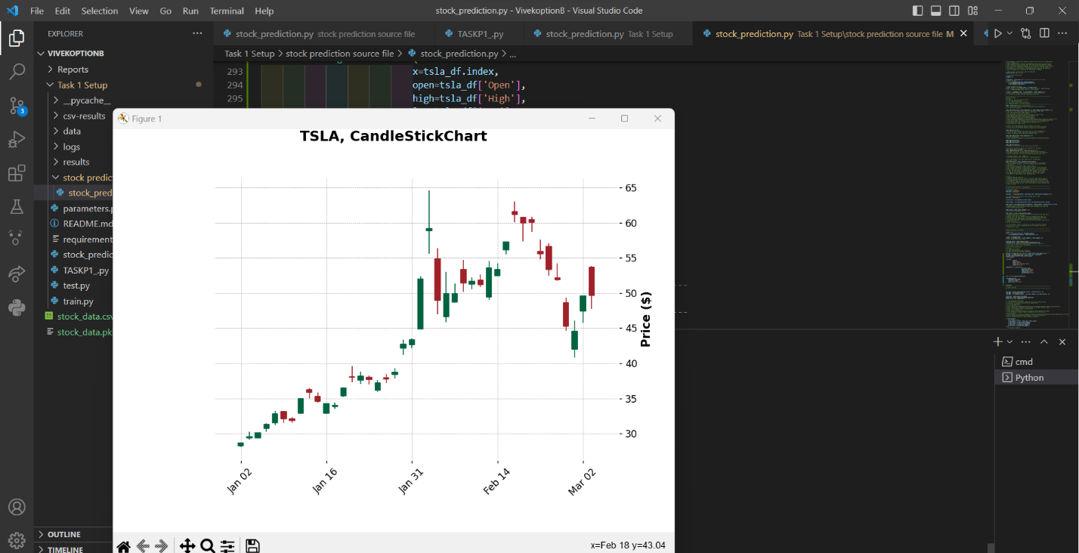

This data has been saved and made into a csv file called as “stock_data.csv” and then passed into a variable.

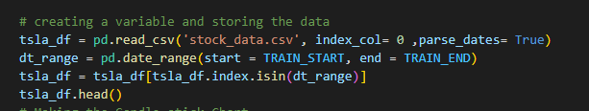

We then move onto using the function to make the candlestick Chart. I imported the mplfinance library to make this work after installing it from pip. There were different types of charts that I discovered like “Charles”, “mike”, “nightclouds” etc. which gives us different types of prebuilt custom charts.

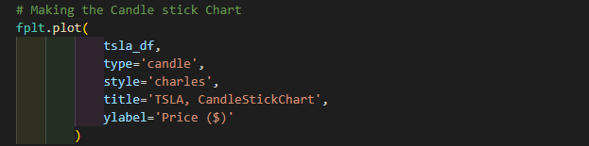

This function will give us a Candlestick Chart. Now some things to keep in mind is that I have used the start date and end date for only 2 months because feeding it more value not only consumes more time to train but also it makes the chart super messy. As I referred to the lecture present in the material given, we can also take the last 30 or maybe 50 values to show in the chart.

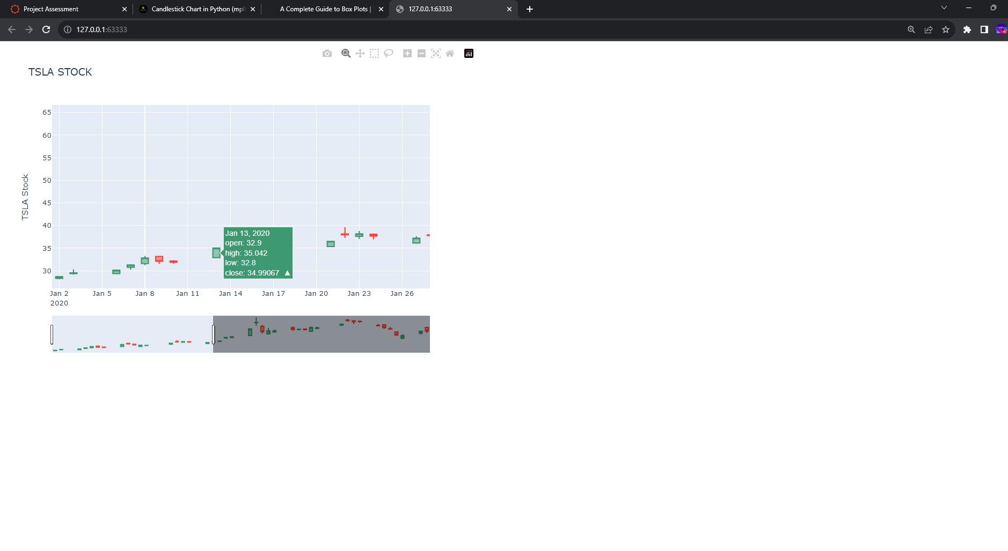

We can adjust the info with a slider that will only show the relevant info according to the number of n trading days that we want to see.

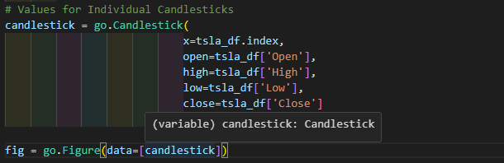

This is the function which was refereed from <https://coderzcolumn.com/tutorials/data-science/candlestick-chart-in-python-mplfinance-plotly-bokeh>

And at last we need to make a boxplot chart , I Used the same dataset I used for the other chart and referred to <https://www.educative.io/answers/how-to-make-a-boxplot-in-pandas> to make the function which results in something like this:

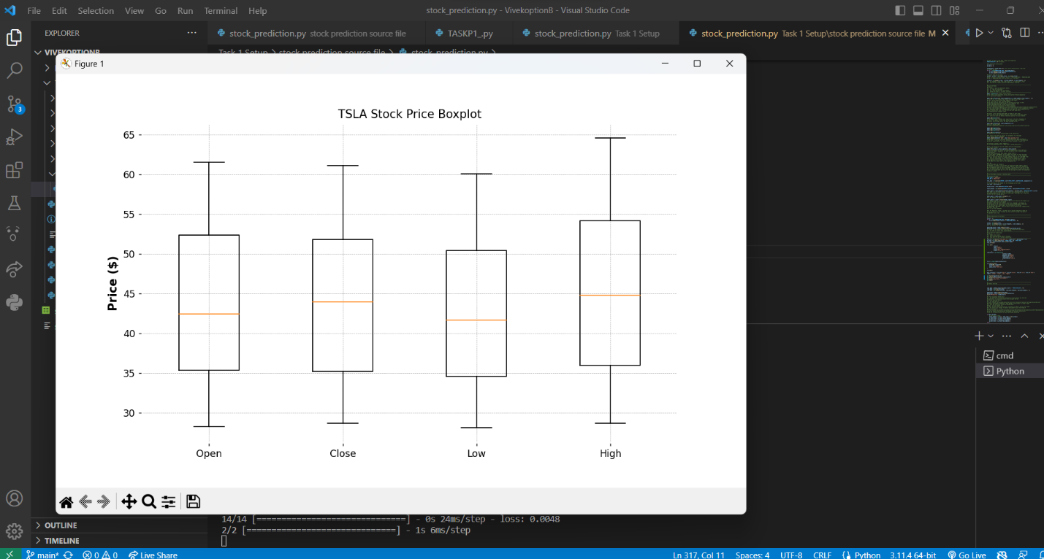

In conclusion, we used the certain libraries that come out from mathplotlib and mplfinance , which helps us to visualize the data and enhanced how we look at the data That we have predicted.